Secret signs - Thieves

Since the dawn of time men have held secrets. Not along after the spoken word and well before the written one, men began to carve signs and symbols to share their knowledge with those who could read the secret tongue. In the beginning man marked the richest of treasures: those of life itself: sources of food, water and shelter. Soon however the primitive scribbling evolved to offer warnings and simple messages. Today rare are those who have inherited this arcane tongue. For this language is not the tongue of learned men or books but of a hardy and selfless people.
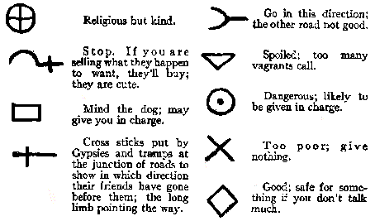
Generally these signs are etched along trails or the entrances to closed areas. This ensures that the “right” sort of traveler will be able to quickly learn about the surrounding environment while ensuring that most remain unaware or simply clueless. The signs or blazes as they’re more commonly known are usually laid on one side of a trick to facilitate recognition. Often interspersed every ½ mile, they are almost always found at an intersection of trails.

